**CRITERION 5**

**Faculty Information and Contributions**

**CAY (2019-20) [N=198( 60+66+72)]**

|  |  |  |  |  |  |  |  |  |  |  |  |  |  |  |  |  |
| --- | --- | --- | --- | --- | --- | --- | --- | --- | --- | --- | --- | --- | --- | --- | --- | --- |
| **SR.No** | **Name of Faculty Member** | | **Qualification** | | **University Year Of Graducation** | | **Designation and Date of joining the institution** | | **Distribution of teaching load (%)** | | | **Academic Research** | | **Years Of Experience** | **Nature of Associa tion(Re gular/ Contra ct)** | **Date Of Leaving** |
|  |  | |  | |  | | **Designation**  **Date of joining** | | **a** | **b** | **c** | **Research paper Publication** | **Faculty Receiving M.Tech/Ph.D. during the Assessment Year** |  |  |  |
| 1 | Mrs. Hange J R | | BE CSE | | SRTMU ( ) | | HOD 06-10-2016 | | **0.5** |  |  | **N** | **N** | 25 |  | 20-09-2019 |
| ME CSE | | SPPU () | |
| 2 | Mr. Chavan S V | | BE CSE | | Shivaji (1989) | | Selection Grade Lecturer  15/07/2014 | | 1 | 0 | 0 | N | N | 31 | Regular |  |
| ME CSE | | Shivaji (2006) | |
| 3 | Ms. Kasar R.D. | | BE CSE | | BAMU (2001) | | Lecturer  01/11/2011 | | 1 | 0 | 0 | N | N | 9 | Regular |  |
| ME CSE | | BAMU (2012) | |
| 4 | Ms. Mulge M.G. | | BE CSE | | SRTMU (2005 ) | | Lecturer  11/07/2007 | | 1 | 0 | 0 | N | N | 13 | Regular |  |
| M.Tech. CSE | | Shivaji (2010) | |
| 5 | Mrs. Patil A S | | BE IT | | Shivaji (2010) | | Lecturer 05/08/2016 | | 1 | 0 | 0 | N | N | 4 | Regular |  |
| ME CSE. | | SPPU (2015) | |
| 6 | Mr. Ambure A.D. | | BE CSE | | Shivaji (2012) | | Lecturer 19/08/2016 | | 1 | 0 | 0 | N | N | 4 | Regular |  |
| M.Tech CSE. | | Shivaji (2015) | |
| 7 | Mr.Dhulgande.C.K | | M.Sc.B.Ed (Mathematics) | | SRTMU (2008) | | Lecturer  05-04-2011 | | 0 | 0.55 | 0 | N | N | 10 | Regular |  |
| 8 | Ms. Khadake N B | | M.Sc. (Chemistry) | | SPPU (2008) | | Lecturer  05-06-2018 | | 0 | 0.44 | 0 | 1 | Persuing Ph.D. | 1 (10 years Reasearch) | Regular |  |
| 9 | Mr. Kakade R.B. | | BE Electrical | | SPPU (2012) | | Lecturer 01-08-2016 | | 0 | 0.55 | 0 | N | N | 4 | Regular |  |
| M.Tech | | Shivaji (2015) | |
| 10 | Mr Hasorikar A R | | MA Eng | | SRTMU (2005) | | Lecturer 12-10-2007 | | 0 | 0.41 | 0 | N | N | 12 | Regular |  |
| 11 | Smt A S Bhandare | | BE ETC | | SRTMU (2005) | | Lecturer  20-07-2016 | | 0 | 0.55 | 0 | N | N | 14 | Regular |  |
| 12 | Mrs. Mahagaonkar R V | | BE EC | | BAMU (1998) | | Lecturer  21-10-2010 | | 0 | 0.5 | 0 | N | N | 18 | Regular |  |
| ME EC | | SRTMU (2005) | |
| 13 | Mr. Kudale P M. | BE ETC | | BAMU (2010) | | Lecturer 01-08-2016 | | |  | 0.5 | 0 | N | N | 6 | Regular |  |
|  | | | | | | | | **Total** | **5.5** | **3.5** | **9.00** | | | | |  |

**Table 1: Faculty Information 2019-2020**

**CAY (2018-19) [N=203 (60+72+71)] 203**

|  |  |  |  |  |  |  |  |  |  |  |  |  |
| --- | --- | --- | --- | --- | --- | --- | --- | --- | --- | --- | --- | --- |
| **Sr.No.** | **Name of Faculty Member** | **Qualification** | **University Year Of Graducation** | **Designation and Date of joining the institution** | **Distribution of teaching load (%)** | | | **Academic Research** | | **Years Of Experience** | **Nature of Associa tion(Re gular/ Contra ct)** | **Date Of Leaving** |
|  |  |  |  |  |  |  |  | **Research paper Publication** | **Faculty Receiving M.Tech/Ph.D during the Assessment Year** |  |  |  |
| 1 | Mrs. Hange J R | BE CSE | SRTMU ( ) | HOD 06-10-2016 | **1** | **0** | **0** | **N** | **N** | 24 | Regular | 20-09-2019 |
| ME CSE | SPPU () |
| 2 | Mr. Chavan S V | BE CSE | Shivaji (1989) | Selection  Grade Lecturer  15/07/2014 | 1 | 0 | 0 | N | N | 30 | Regular |  |
| ME CSE | Shivaji (2006) |
| 3 | Ms. Kasar R.D. | BE CSE | BAMU (2001) | Lecturer  01/11/2011 | 1 | 0 | 0 | N | N | 8 | Regular |  |
| ME CSE | BAMU (2012) |
| 4 | Ms. Mulge M.G. | BE CSE | SRTMU (2005 ) | Lecturer  11/07/2007 | 1 | 0 | 0 | N | N | 12 | Regular |  |
| M.Tech. CSE | Shivaji (2010) |
| 5 | Mrs. Patil A S | BE IT | Shivaji (2010) | Lecturer  05/08/2016 | 0.52 | 0 | 0 | N | N | 3 | Regular |  |
| ME CSE. | SPPU (2015) |
| 6 | Mr.Dhulgande.C.K | M.Sc.B.Ed (Mathematics) | SRTMU (2008) | Lecturer 05-04-2011 | 0 | 0.55 | 0 | N | N | 9 | Regular |  |
| 7 | Mr Hasorikar A R | MA Eng | SRTMU (2005) | Lecturer 12-10-2007 | 0 | 0.33 | 0 | N | N | 11 | Regular |  |
| 8 | Mr. Kakade R.B. | BE Electrical | SPPU (2012) | Lecturer 01-08-2016 | 0 | 0.55 | 0 | N | N | 3 | Regular |  |
| M.Tech | Shivaji (2015) |
|  |  |  |  | **TOTAL** | **4.52** | **1.43** | **5.95** | | | | |  |

**Table 2: Faculty Information 2018-2019**

**CAY (2017-18) [N=207 (60+71+76)]= 207**

|  |  |  |  |  |  |  |  |  |  |  |  |  |
| --- | --- | --- | --- | --- | --- | --- | --- | --- | --- | --- | --- | --- |
| **Sr.No.** | **Name of Faculty Member** | **Qualification** | **University Year Of Graducation** | **Designation and Date of joining the institution** | **Distribution of teaching load (%)** | **Academic Research** | | | | **Years Of Experience** | **Nature of Associa tion(Re gular/ Contra ct)** | **Date Of Leaving** |
|  |  |  |  |  |  |  |  | **Research paper Publication** | **Faculty Receiving M.Tech/Ph.D during the Assessment Year** |  |  |  |
| 1 | Mrs. Hange J R | BE CSE | SRTMU ( ) | HOD 06-10-2016 | 1 | 0 | 0 | N | N | 23 | Regular | 20-09-2019 |
| ME CSE | SPPU () |
| 2 | Mr. Chavan S V | BE CSE | Shivaji (1989) | Selection Grade Lecturer 15/07/2014 | 1 | 0 | 0 | N | N | 29 | Regular |  |
| ME CSE | Shivaji (2006) |
| 3 | Ms. Kasar R.D. | BE CSE | BAMU (2001) | Lecturer 01/11/2011 | 1 | 0 | 0 | N |  | 07 | Regular |  |
| ME CSE | BAMU (2012) |
| 4 | Ms. Mulge M.G. | BE CSE | SRTMU (2005 ) | Lecturer 11/07/2007 | 1 | 0 | 0 | N | N | 11 | Regular |  |
| M.Tech. CSE | Shivaji (2010) |
| 5 | Mrs. Patil A S | BE IT | Shivaji (2010) | Lecturer 05/08/2016 | 1 | 0 | 0 | N | N | 2 | Regular |  |
| ME CSE. | SPPU (2015) |
| 6 | Mr.Dhulgande.C.K | M.Sc.B.Ed (Mathematics) | SRTMU (2008) | Lecturer 05-04-2011 | 0 | 0.55 | 0 | N | N | 8 | Regular |  |
| 7 | Mr Hasorikar A R | MA Eng | SRTMU (2005) | Lecturer 12-10-2007 | 0 | 0.11 | 0 | N | N | 10 | Regular |  |
| 8 | Mr. Kakade R.B. | BE Electrical | SPPU (2012) | Lecturer 01-08-2016 | 0 | 0.52 | 0 | N | N | 2 | Regular |  |
| M.Tech | Shivaji (2015) |
| 9 | Mr. Kudale P M. | BE ETC | BAMU (2010) | Lecturer 01-08-2016 | 0 | 0.33 | 0 | N | N | 6 | Regular |  |
| 10 | Mr. Rathod J C | ME Mech | Solapur (2017) | Lecturer 15/12/2017 | 0 | 0.00 | 0 | N | N | 1 | Regular |  |
|  |  | | | **TOTAL** | **5** | **1.51** | **6.51** | | | | |  |

**Table 3: Faculty Information 2017-2018**

***Note: Please provide the above table for the CAY, CAYm1, CAYm2 and CAYm3 where,***

**CAY – Current Academic Year**

**CAYm1- Current Academic Year minus1= Current Assessment Year**

**CAYm2 - Current Academic Year minus2=Current Assessment Year minus 1 CAYm3- Current Academic Year minus3=Current Assessment Year minus 2**

* 1. **Student-Faculty Ratio (SFR) (25)**

S: F ratio = N/F; F = No. of faculty = (a + b) for every assessment year   
a: Faculty of the specific program/ department considering fractional load

b: Faculty serving this program from other Program / department considering fractional load

c: Faculty of this program serving other program/ department considering fractional load.

## Note: Fractional load calculation

**1: Faculty taking physics course is having 50% of allocated load of first year civil engineering students, 25% load of first year mechanical engineering and 25% load of electrical engineering then the fractional load contribution will be 0.50 for civil engineering, 0.25 each for mechanical and electrical engineering.**

**2: Similarly fractional load to be calculated for inter department/program work load distribution.**

**Regular Faculty means:**

Minimum 75% should be Regular/ full time faculty and the remaining shall be Contractual Faculty as per AICTE norms and standards.

The contractual faculty (doing away with the terminology of visiting/adjunct faculty, whatsoever) who have taught for 2 consecutive semesters in the corresponding academic year on full time basis shall be considered for the purpose of calculation in the Student Faculty Ratio.

N=No. of students = Sanctioned Intake + Actually admitted lateral entry students

|  |  |  |  |  |
| --- | --- | --- | --- | --- |
| **Year** | **Actual Intake** | **Lateral entry** | | **Total** |
|  |  | **CAYm1** | **CAYm2** | **N=(180+(CAYm1+CAYm2))** |
| CAY(2019-20) | 180 | 06 | 12 | 198 |
| CAYm*1(2018-19)* | 180 | 12 | 11 | 203 |
| CAYm*1(2017-18)* | 180 | 11 | 16 | 207 |

**Table 5.1.1: Student Intake**

|  |  |  |  |
| --- | --- | --- | --- |
| **Year** | **N** | **F** | **SFR=N/F** |
| CAY (2019-20) | 198 | 9.00 | 22.00 |
| CAYm*1* (2018-19) | 203 | 5.95 | 34.12 |
| CAYm2 (2017-18) | 207 | 6.51 | 31.80 |
| **AVG SFR** | | | **29.31** |

**Table 5.1.2:SFR Calculation**

## Marks to be given proportionally from a maximum of 25 to a minimum of 10 for average SFR between 25:1 to 30:1, and zero for average SFR higher than 30:1. Marks distribution is given as below: < = 25 - 25 Marks

**< = 26 - 22 Marks**

**< = 27 - 20 Marks**

**< = 28 - 15 Marks**

**< = 29 - 12 Marks**

**< = 30 - 10 Marks**

**>30-00 Marks**

* + 1. **Provide the information about the regular and contractual faculty as per the format mentioned below:**

|  |  |  |
| --- | --- | --- |
| **Year** | **Total No of Regular Faculty in Department** | **Total No of Contractual Faculty in Department.** |
| **CAY (2019-20)** | **6** | **NA** |
| **CAYm*1* (2018-19)** | **5** | **NA** |
| **CAYm2 (2017-18)** | **5** | **NA** |

**Table 5.1.1.1:Regular & Contractual Faculty**

## Faculty Qualification (25)

**5.2.1 Faculty Qualification Index (20)**

|  |  |  |  |  |
| --- | --- | --- | --- | --- |
| **YEAR** | **X (M-Tech)** | **Y (B. Tech)** | **F** | **FQ= 2*(10x+7y)/F** |
| 2019-20 | 8 | 5 | 7.92 | 29.05 |
| 2018-19 | 6 | 2 | 8.12 | 18.23 |
| 2017-18 | 6 | 3 | 8.28 | 19.57 |
| Total | | | | 66.85 |
| **Average Assesment** | | | | **22.28** |

**Table 5.2.1: Faculty Qualification Index**

FQ = 2.0* (10x +7y)/F where x is no. of faculty with M.Tech. (in case of humanities and science M.Phil./Ph.D.) and y is no. of faculty with B.Tech. (In case of humanities and science MA/M.sc), F is no. of faculty required to comply 1:25 Faculty Student Ratio

**5.2.2 Availability of Faculty/principal of that discipline with PhD Qualification (05)**

## 

## Nil

## 5.3 Faculty Retention (20)

|  |  |
| --- | --- |
| **Item** | **Marks** |
| (% of faculty retained during the period of assessment keeping CAYm3 as base year) | Marks |
| >= 90% of required Faculties retained averaged over the period of assessment keeping CAYm3 as base year | 20 |
| >= 75% of required Faculties retained averaged over the period of assessment keeping CAYm3 as base year | 15 |
| >= 60% of required Faculties retained averaged over the period ofassessment keeping CAYm3 as base year | 10 |
| >= 50% of required Faculties retained averaged over the period of assessment keeping CAYm3 as base year | 5 |
| <50% of required Faculties retained averaged over the period of assessment keeping CAYm3 as base year | 0 |

|  |  |  |  |
| --- | --- | --- | --- |
| **Description** | **CAYm2(2017-18)** | **CAYm1(2018-19)** | **CAY(2019-20)** |
| Total no. of Faculty | 6 | 5 | 6 |
| Faculty Retained | 5 | 5 | 5 |
| **Percentage of Faculty Retained** | **83%** | **100%** | **83%** |

**Table 5.3:Faculty Retention**

## Note: Total sanctioned post is HOD: 01

**Lecturer: 05 (All posts are transferable due to government organization)**

**5.4 Faculty as participants in Faculty Development /training activities conducted by other organizations (30)**

* A Faculty scores maximum five points for participation
* Participant in 1 to 2 days Faculty/faculty development program: 1 Points
* Participant in 3 to 5 days Faculty/faculty development program: 2 Points
* Participant >5 days Faculty/faculty development program: 5 points

|  |  |  |  |
| --- | --- | --- | --- |
| **Name of the Faculty** | **Max. 5 per Faculty** | | |
| **CAYm2 2017-18** | **CAY m1 2018-19** | **CAY 2019-20** |
| Mrs. Hange J. R. | 5 | 2 | 2 |
| Mr. Chavan S. V. | 4 | 0 | 2 |
| Mr. Kendre S. V. | 0 | 0 | 0 |
| Ms. Kasar R. D. | 5 | 2 | 5 |
| Ms. Mulge M. G. | 0 | 5 | 5 |
| Mrs. Patil A. S. | 5 | 2 | 5 |
| Mr.Ambure A.D. | 0 | 2 | 4 |
| Mr.Dhulgande.C.K | 0 | 0 | 5 |
| Ms. Khadake N V | 0 | 0 | 5 |
| Mr. Kakade R.B. | 0 | 0 | 5 |
| Mr Hasorikar A R | 2 | 2 | 0 |
| Smt A S Bhandari | 0 | 0 | 5 |
| Mrs. Mahagaonkar R V | 5 | 0 | 5 |
| Mr. Kudale P M. | 0 | 5 | 2 |
| Mr. Rathod J C | 0 | 2 | 5 |
| **Sum** | **26** | **22** | **55** |
| ***RF*= Number of Faculty required to comply with 25:1 Student-Faculty ratio as per 5.1** | **8.28** | **8.12** | **7.92** |
|
| **Assessment = 6 × Sum/0.5RF (Marks limited to 30)** | **37.7** | **32.6** | **83.4** |
|
| **Average assessment over three years (Marks limited to 30)** | | | **51.23** |
|

**Table 5.3:Faculty Training**

**5.4. Organized/ Conducted FDPs and STTP by this department at State / National Level (12)**

NIL

• Minimum 2 days program

• 2 points per program (max. upto 12 marks)

## Product development, Consultancy, Manufacturing contracts, testing contracts (8)

**5.5.2 Testing contracts**

In Our Department Testing of Computers, Laptops & Printers is done by department faculty as below-

|  |  |  |  |
| --- | --- | --- | --- |
| **Sr. No** | **Name OF Office** | **Items of Testing** | **Amount Deposited** |
| 1 | Mahila Arthik Vikas Mahamandal ,Dist Office,Latur | Laptop-1 Printer - 1 | 1122 |
| 2 | Tejswini Loksanchlit Sadhan Kendra,Shirur Tal, Tal. Ahamadpur | Computer-1 Printer -1 | 1022 |
| 3 | Zashichi Rani Loksanchlit Sadhan Kendra,Shirur Tal, Tal. Ausa | Computer-1 Printer -1 | 1022 |
| 4 | Ekata Loksanchlit Sadhan Kendra,Latur(West) | Computer-1 Printer -1 | 1022 |
| 5 | Jayhind Loksanchlit Sadhan Kendra,Latur(East) | Computer-1 Printer -1 | 1022 |
| 6 | Pragati Loksanchlit Sadhan Kendra, Murud | Computer-1 Printer -1 | 1022 |
| 7 | Savitribai Phule Loksanchlit Sadhan Kendra,Renapur | Computer-1 Printer -1 | 1022 |
| **Total Amount in Rs.** | | | **7254** |

**Table 5.5.2 : Testing Contracts**

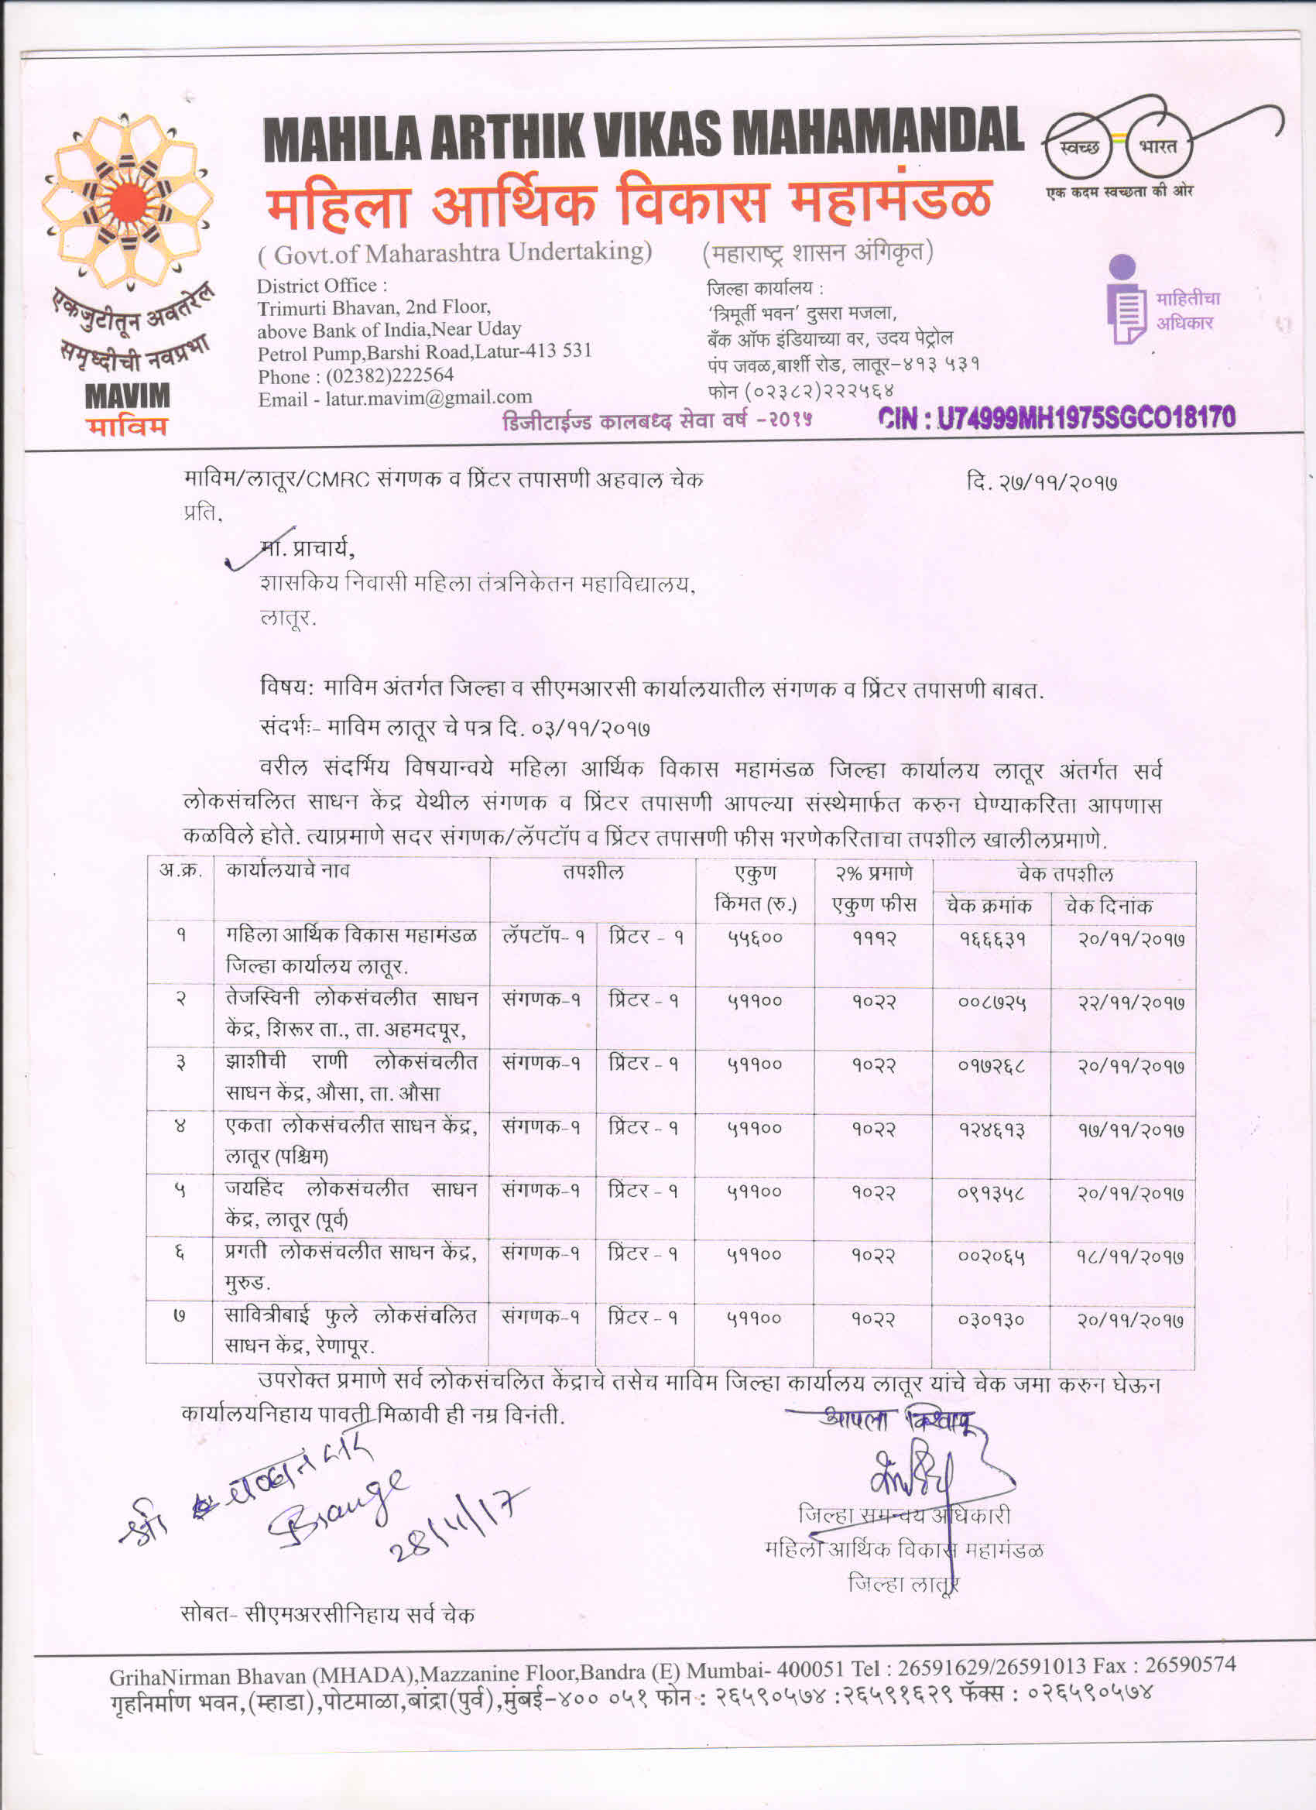

**Image 5.5.2: Testing Contracts Order**

**5.6. Faculty Performance Appraisal and Development System (FPADS)(30)**

**5.6 a. A well- defined FPADS instituted for all the assessment years (05)**

The job/role of a teacher is not limited only to the class room but is multifarious to achieve overall development of students. The teacher has to make efforts to impart modern technologies or professional methods to the students. He has to exert for updating his knowledge and skills. A large number of teachers do take keen interest in all the activities conducive to the welfare of the student community in order to build the personality of the students and to maintain a clean image of the institution. Some teachers show excellent performance in administrative and managerial assignments too. However, the earlier system of confidential reports does not project the entire range of performance of a teacher. Every organization needs to ensure right kind of people, at right places, at right time to achieve its objectives, targeted mission and vision. It is therefore essential to give recognition to those who are conscientious of their responsibilities. Recognition may be with providing opportunities of accelerated promotions or awards. It is equally necessary to produce disincentives for indifferent and in some cases unscrupulous teachers showing poor performance. The UGC and AICTE have recommended the package of pay scales for teachers with conditions to implement Performance Appraisal Development System. Therefore there is a need to adapt a suitable format for Performance Appraisal of teachers that encompasses the entire range of functions and permits differentiation based on quantified weight.

Government has considered recommendations of the University Grant Commission and of the All India Council for Technical Education and implemented the package of pay scales for the teachers. The main objective was to maintain standards of higher and technical education. Accordingly, resolutions issued by the Government from time to time specified the terms and conditions of service. The statutory bodies recommended devising and implementing the effective performance appraisal to promote efficiency and effectiveness of the system. These recommendations emphasize the need to help individual teachers to grow, develop and advance on merit. The UGC and AICTE have also devised guidelines on the Performance Appraisal. However, to make it more quantitative, more conducive to the local factors some minor modifications were proposed by the Directorates and further deliberations of Government, Grant –in-aid, Un-aided degree and diploma level institutions from all over the state. The participant institute has made valuable suggestions.

**Government Resolution:**

Taking into consideration modifications and suggestions given by directorates and deliberations of the various degree and diploma institutions from the state. State Government accorded an approval to the implementation of the scheme of "Performance Appraisal and Development Systems" for teachers and administrative posts in Government and Grant-in- aid educational institutions in Engineering, Architecture, Pharmacy, Management studies, Art education and also in Government Arts, Science, Commerce, Law, Education degree and diploma institutes under the control of Higher and Technical Education and Employment Department with effect from 1-4-1997 vide GR No. Higher and Technical Education and Employment it Department, CRF 1096(20/96) TE -4 dated 25th march 1997 and further directed that the performance appraisal report shall be appended to the annual confidential reports.

As per the prescribe "Performance Appraisal and Development Systems" format is for period of one year and assessment of performance is carried out on various academic, administrative and managerial indicators as given below.

* **Academic indicators assessment**

1. Performance of engaging lecture

2. Performance of attendance of students

3. Performance of results

Assessments of academic performance indicators measures aptitude for teaching and efforts taken, to make lectures interesting, dedicated efforts to improve teaching skills and involvement of students in learning process, examinations results of regular students. Average of results of last three years of particular course.

**Administrative and managerial indicators assessment**

This measures various qualities, functions and behavioral accepts of teachers

Government residential Women’s Polytechnic, Latur, such as industriousness, administrative and proportional capability, resources fullness, initiative, drive, judgment, behavior commitment, leadership qualities etc. To measure the performance of each indicator 4 point scale viz. Excellent, Good, Average and Poor has been specified for administrative and managerial indicators assessment. Multiplying factors 2.0, 1.4, 1.0, and 0.4 are assigned for 4 point scale respectively as mentioned above.

* **Final assessment**

The final assessment grade is given by reporting officer considering total weight achieved in academic, administrative and managerial functions out of 100.The special weight maximum to 05 can be awarded by reporting officer for extra ordinary contribution for the institutional development.

|  |  |  |
| --- | --- | --- |
| **Weight of performance** | **Grade** | |
| 100-81 | Out standing | A+ |
| 080-071 | Excellent/Very Good | A |
| 070-061 | Positively Good | B+ |
| 060-051 | Good | B |
| 050-035 | Average | B- |
| 034-000 | Below Average | C |

**Table 5.6.1: Faculty Performance grading Scale**

From the year 2016-17 General Guidelines for writing Performance Appraisal Reports of State Government Grade A Officers are issued vide State Government Resolution, General Administration Department, No.: CFR-1211/C.R. 257/XIII, dated 02.02.2017.The UGC and AICTE have also devised guidelines on the Performance Appraisal. However, to make it more quantitative, more conducive to the local factors some minor modifications were proposed by the Directorates and further deliberations of Government, Grant –in-aid, Un-aided degree and diploma level institutions from all over the state. The participant institute has made valuable suggestions.

The same format has been prescribed for the post of Lecturer in E &T, senior grade Lecturer in E &T, and Select grade Lecturer in E &T, Reader, and designated Reader, Assistant Professor, Professor and other similar administrative post. A separate format has been prescribed for Head of the department and similar posts similarly a separate format has been prescribed for the post of Principal/ Head of the institution, however, these formats shall not be applicable to fully administrative posts.

In which assessment of performance of the Grade A officer is carried out on the basis of three performance attributes i.e.

* + Work completion (weight age40%),
  + Personal attributes(weight age 30%)and
  + Efficiency (weight age30%).

Following points are accessed by reporting officers and review officer.

|  |  |  |
| --- | --- | --- |
| **Work Completion (40% )** | **Personal Attributes (30%)** | **Efficiency (30%)** |
| Accomplishment of planned work | Attitude to Work | Knowledge of relevant acts |
| Quality of Output | Overall Bearing and Personality | Decision making Ability |
| Average Gradation on Work Completion | Emotional Stability | Initiative |
|  | Communication skills | Ability to coordinate |
|  | Capacity to work in Time Limit | Average Gradation on Work Efficiency |
|  | Average gradation on Personal attribute |  |

**Table 5.6.2: Faculty Performance grading Scale**

# Performance appraisal Gradation

Weights have been assigned to work output, personal attributes and efficiency. The overall grade will be based on the addition of the mean value of each group of indicators in proportion to weight age assigned. The formulae for the calculation of “Overall Gradation” will be as follows –

***(Average Grade on Work Completion * 4) + (Average Grade on Personal Attributes *3) + (Average Grade on Efficiency *3) divided by 10***

Overall grade in the numerical scale of 1-10 is to be given by reporting authority. Where 1 refers to the lowest grade and 10 to the highest grade.

|  |  |
| --- | --- |
| **Numerical Gradation for Performance** | **Grade** |
| Overall Gradation of 1 and 2 | C |
| Overall Gradation of 3 to 5 | B |
| Overall Gradation of 6 to 8 | A |
| Overall Gradation of 9 and 10 | A+ |

Disclosure There is more openness in the system of appraisal. The annual PAR, including the overall grade and integrity, are communicated to the officer reported upon after it has been finalized.

The officer reported upon may have the option to give his representation against the below benchmark gradation recorded in the PAR. Such representation may be restricted to the specific factual observations contained in the Performance Appraisal

Report leading to the assessment of the officer in terms of attributes, competency, output and overall gradation. From the year 2017-18 Government of Maharashtra has adopted new policy for maintaining the performance appraisal (PAR) of Grade A and B officers in their state government services, vide State Government Resolution, General Administration Department, No.: CFR-1211/C.R. 257/XIII, dated 07.02.2018.Also separate formats for technical officers are finalized and decided to implement vide State Government Resolution, General Administration Department, No.: CFR-1211/C.R.8/XIII, dated 05.03.2018.

In which on line details of Confidential/Assessment Reports are to be filled on MAHAPAR Computerized System of the Department. General Guidelines for writing Performance Appraisal Reports of State Government Grade A and B Officers are issued vide above Resolutions.

The overall gradation system of assessment is kept same as mentioned in the previous year.i.e. 2016-17.

**The performance appraisal format is given below:**

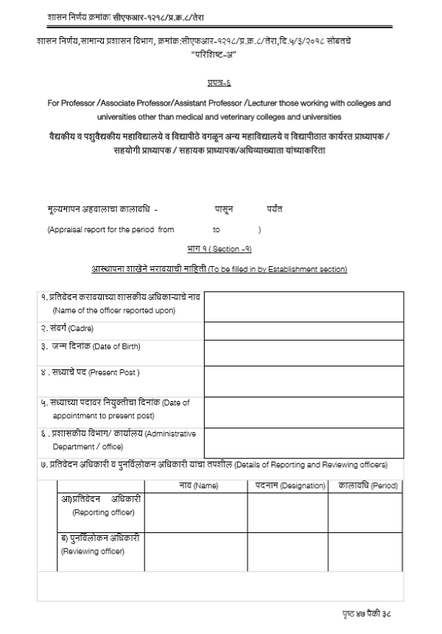

**Image 5.6.1: Performance Appraisal Format**

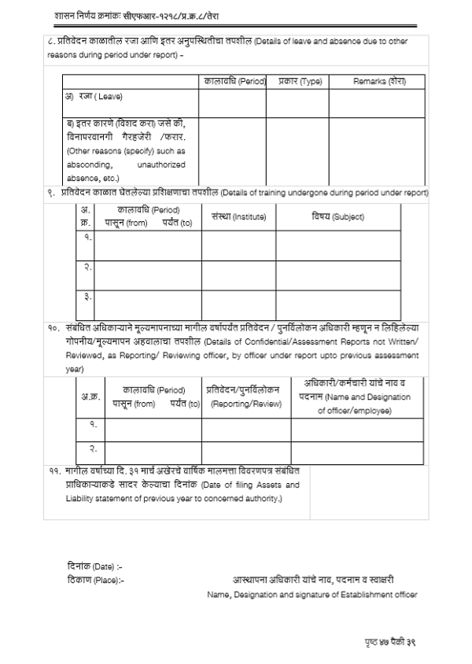

**Image 5.6.2: Performance Appraisal Format**

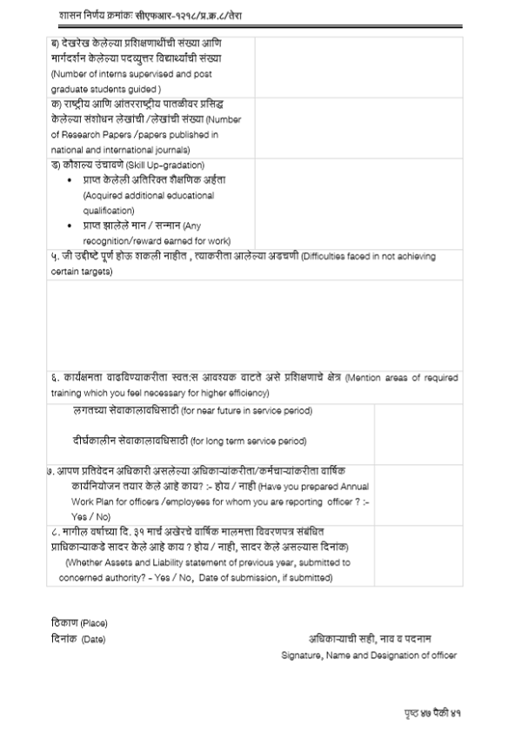

**Image 5.6.3: Performance Appraisal Format**

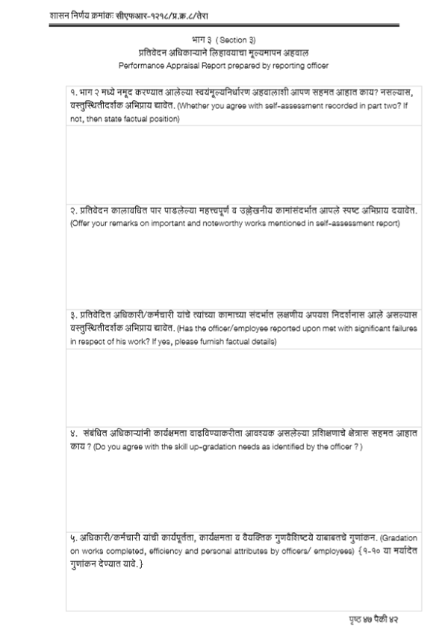

**Image 5.6.4: Performance Appraisal Format**

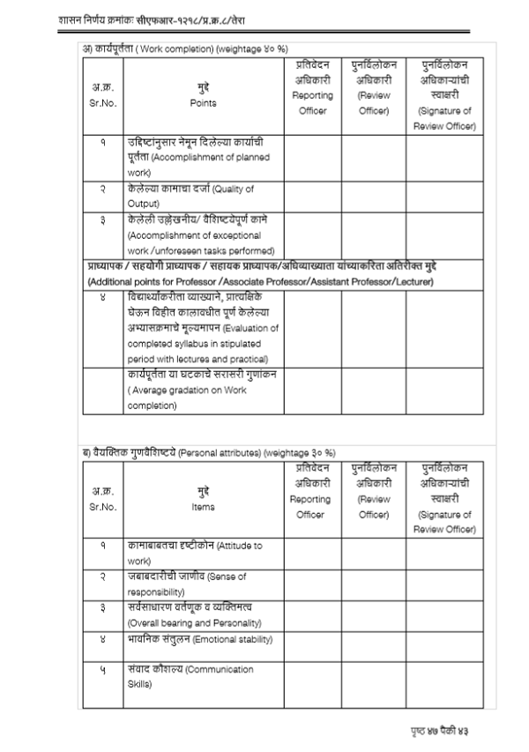

**Image 5.6.5: Performance Appraisal Format**

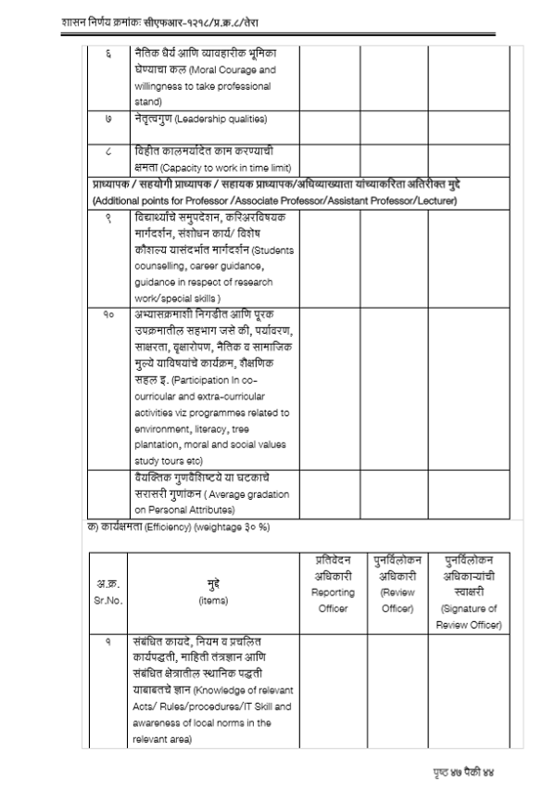

**Image 5.6.6: Performance Appraisal Format**

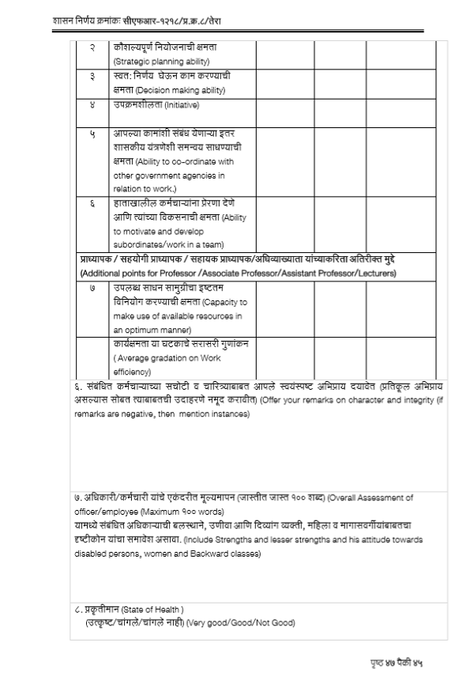

**Image 5.6.7: Performance Appraisal Format**

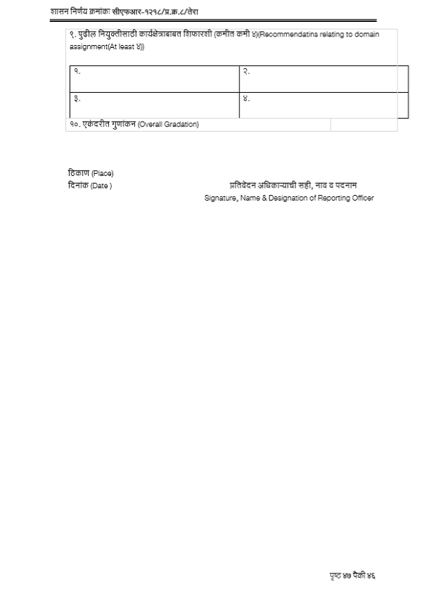

**Image 5.6.8: Performance Appraisal Format**

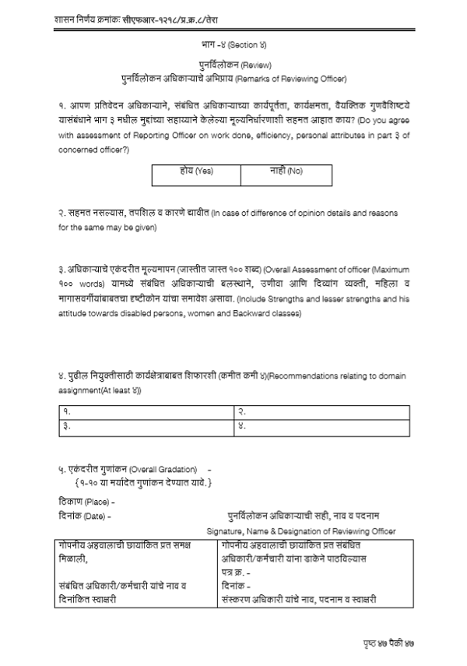

**Image 5.6.9: Performance Appraisal Format**

**5.6. b Implementation and Effectiveness(15):**

* A well defined faculty performance appraisals system is established by Government of Maharashtra.
* The faculty Performance Appraisal and Development System(FPADS) is implemented for faculty members at all levels i.e. Principal, Head of Department and Lecturer.
* These separate performance parameters/criteria are being developed for Principal, Head of Department and Lecturer.
* The performance appraisal of lecturer is assessed by Head of Department and reviewed by Principal.
* The performance appraisal of Head of Department is assessed by principal and reviewed by Joint Director.
* The performance appraisal of Principal is assessed by Joint Director and reviewed by Director.

**Activity Flow Chart (FPADS)**



**Image 5.6.1: Flow Chart of FPADS**

## Details of qualification up-gradation of faculty (10)

Normally all regular faculties in department are selected through Maharashtra Public Service Commission & had been gone through screening based on Experience & Higher qualification. Minimum qualification for a Lecturer in Government Polytechnics is Bachelor of Engineering (B.E.). But in MPSC interview they mostly prefer the candidates who have higher qualification & experience.

In our department visiting faculties are also gone through such type of screening & selection procedure at institute level. So all faculties are well experienced & highly educated.

The following faculty members of Computer Engineering Department have done their qualification up-gradation.

|  |  |  |
| --- | --- | --- |
| **Name of the Faculty** | **Qualification up-gradation** | **Year Of Passing** |
| Mr. Chavan S.V. | M.E(CSE) | 2006 |
| Ms. M. G. Mulge | M. Tech(CSE) | 2010 |